SATISH CHANDRA MEMORIAL SCHOOL
Practice Test (HOTS)
SCIENCE
CLASS- VI
Time: 40 Minutes Maximum Marks: 16
____________________________________________________________________________

- While measuring the length of a knitting needle, the reading of the scale at one end is 3.8 cm and at the other end is 33.5 cm. What is the length of the needle? (1)
- The picture given below depicts an activity to demonstrate the release of excess water in the form of vapour by plants. (1+1 ½+ ½ +½)
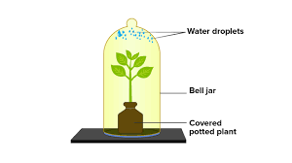
- Why is it necessary to cover the plant with a bell jar?
- If the plant is replaced with a dried stem without any leaves, will there be any change in your observations and why?
- Name the part of the leaf through which the process mentioned here takes place.
- Mention any one advantage of the given process.

- Both A and B exhibit the same type of motion. (½+1+1)
- Identify the motion which is common to A and B.
- How is the motion mentioned in part a different from translational motion?
- If the cyclist covers 30 km with a speed of 15 km/hr, find the time taken by the cyclist to complete the journey.
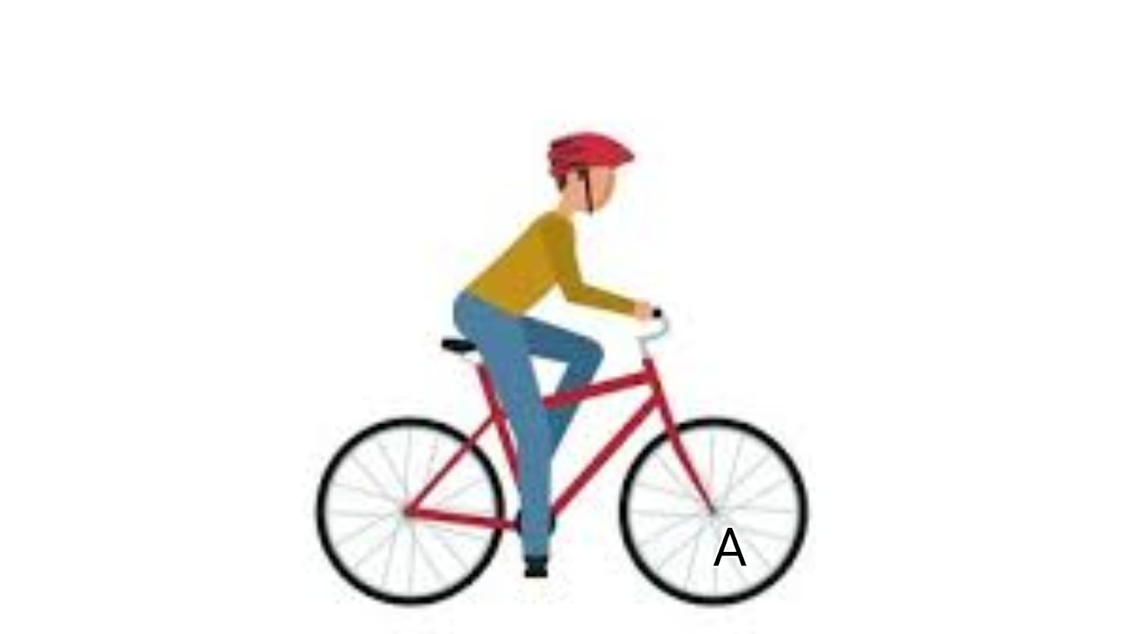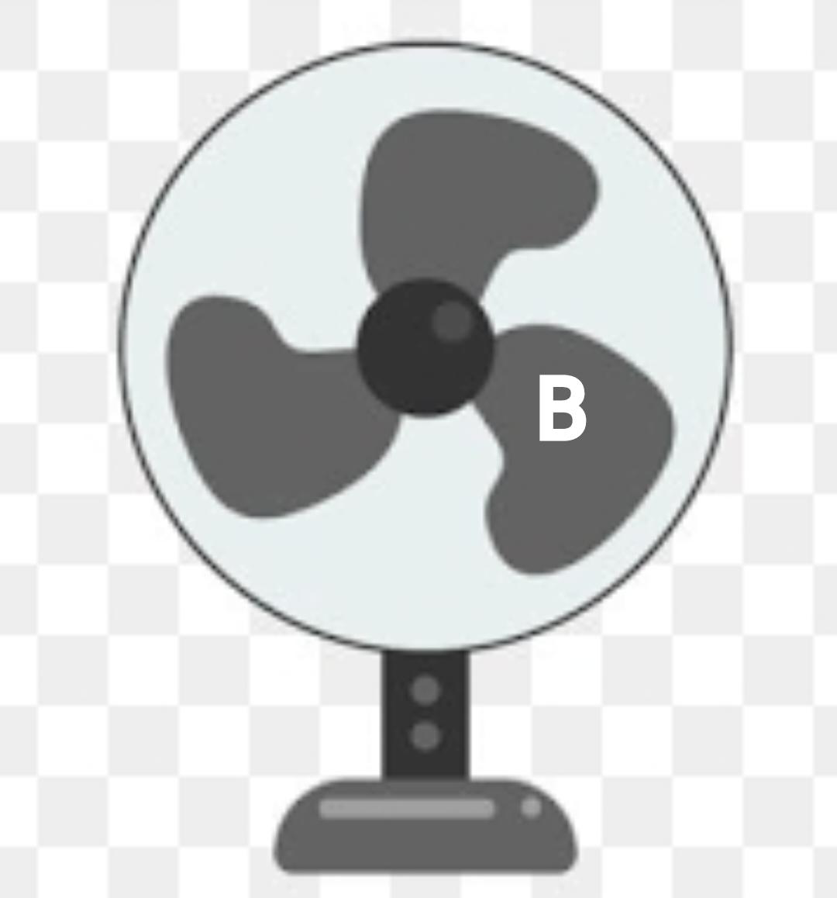
- An experiment was conducted by class 6 students to check the solubility/ miscibility of some substances in water. They recorded the following observations. (2+1)

Substance | P (solid) | Q (liquid) | R (liquid) | S (solid)
Soluble in water (Yes/No) | Yes | No | Yes | No

- Identify P, Q, R and S from the list of substances given below
vinegar, sand, mustard oil, sugar
- Suggest a method to separate the following mixtures
i. S and water
ii. P and water

- The distance between Radha’s home and school is 2.5 km. Radha goes to school and returns home. If she attends school every day from Monday to Friday, what is the total distance travelled by Radha (in km)? (1)
- Look at the picture given below and answer the questions that follow. (2+1)
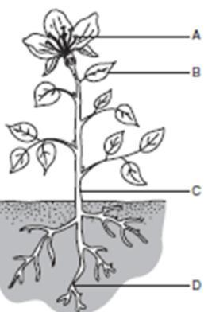
- Identify A, B, C and D
- Which of A, B, C and D can be described by the following?
- This absorbs water and minerals from the soil.
- This helps to produce a cooling effect on the plant.

7. a. Sima wanted to buy a utensil for making curry using a gas oven. Given below are a list of characteristics of materials. (1)
- Flexible II. Good conductor of electricity III. Transparent
IV. Magnetic in nature V. Light and strong VI. Brittle VII. Good conductor of heat
Choose two characteristics from the above list which the material of the utensil must have.
b. A man wanted to use plastic for making wires. Did he choose the right material? Give reason. (1)

